**Making an Array in bash script: -**

* #! /usr/bin/bash

Declare -a sports= (

[0]=Basketball,

[1]=Football,

[2]=Volleyball

)

**Screenshot: -**

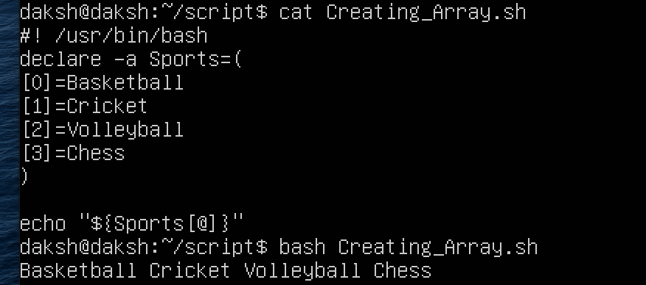

**Comparison Operators: -**

|  |  |  |
| --- | --- | --- |
| **OPERATIONS** | **SYNTAX** | **EXPLANATION** |
| Equality | Num1 -eq Num2 | Is num1 equal to num2 |
| Less than equal to | Num1 -le Num2 | Is num1 less than equal to num2 |
| Less than | Num1 -lt Num2 | Is num1 less than num2 |
| Greater than equal to | Num1 -ge Num2 | Is num1 greater than equal to num2 |
| Greater than | Num1 -gt Num2 | Is num1 greater than num2 |
| Not equal to | Num1 -ne Num2 | Is num1 not equal to num2 |

**Screenshot: -**

